**Candidate Name :- Abhishek Gowda M**

**Superset ID :- 6431229**

**WEEK – 2 HANDS ON EXERCISE (JAVA FSE DEEPSKILLING) (PL/SQL PROGRAMMING)**

**Exercise 1: Control Structures**

Scenario 1 : The bank wants to apply a discount to loan interest rates for customers above 60 years old.

Question : Write a PL/SQL block that loops through all customers, checks their age, and if they are above 60, apply a 1% discount to their current loan interest rates.

**Code for the above question:-**

BEGIN

EXECUTE IMMEDIATE 'DROP TABLE loan_customers';

EXCEPTION

WHEN OTHERS THEN

NULL;

END;

/

CREATE TABLE loan_customers (

customer_id NUMBER,

interest_rate NUMBER,

age NUMBER

);

INSERT INTO loan_customers VALUES (101, 10.5, 69);

INSERT INTO loan_customers VALUES (102, 12.0, 65);

INSERT INTO loan_customers VALUES (103, 9.5, 57);

INSERT INTO loan_customers VALUES (104, 11.5, 77);

COMMIT;

SET SERVEROUTPUT ON;

DECLARE

CURSOR customer_cursor IS

SELECT customer_id, interest_rate, age FROM loan_customers;

v_new_rate NUMBER;

BEGIN

FOR rec IN customer_cursor LOOP

IF rec.age > 60 THEN

v_new_rate := rec.interest_rate * 0.99;

UPDATE loan_customers

SET interest_rate = v_new_rate

WHERE customer_id = rec.customer_id;

DBMS_OUTPUT.PUT_LINE('1% discount applied for customer ID: ' || rec.customer_id);

END IF;

END LOOP;

COMMIT;

END;

/

**OUTPUT:**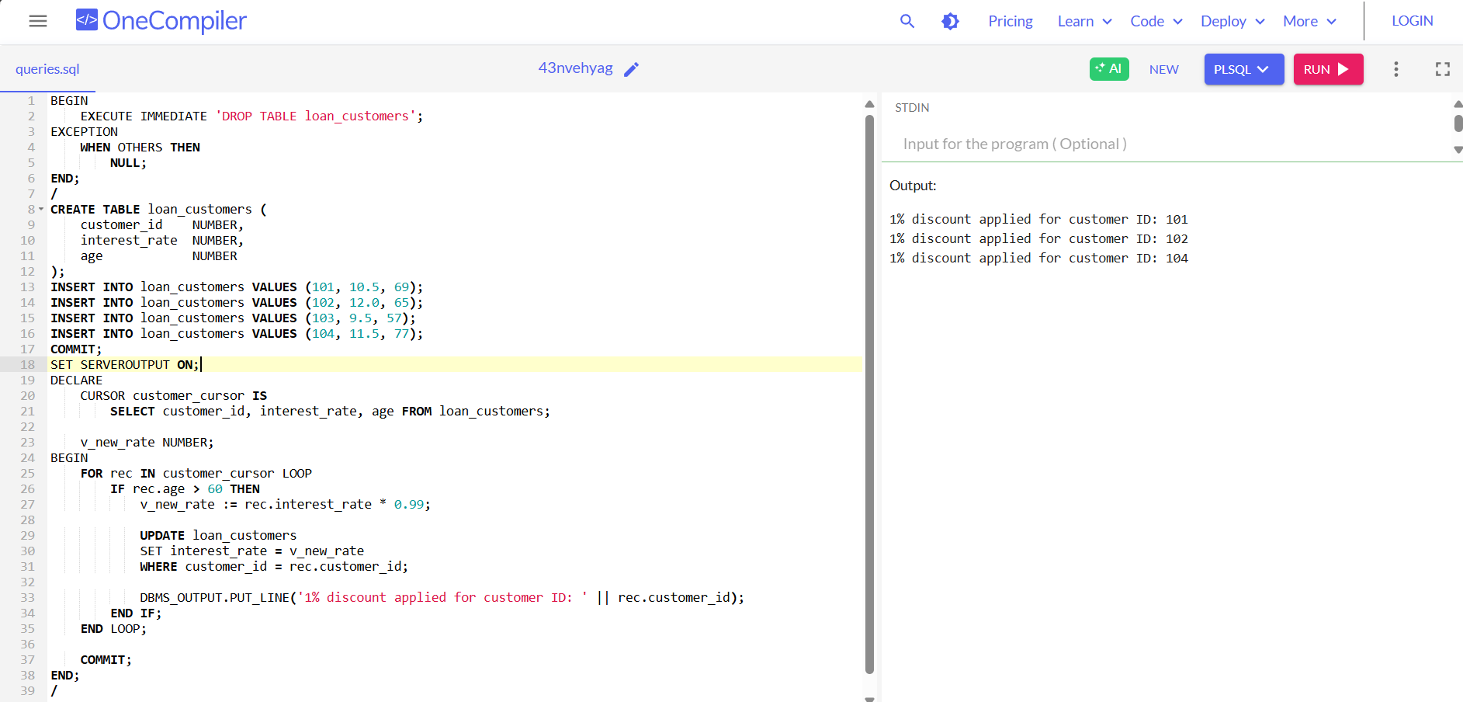

**Scenario 2 : A customer can be promoted to VIP status based on their balance.**

Question : Write a PL/SQL block that iterates through all customers and sets a flag IsVIP to TRUE for those with a balance over $10,000..

**Code for the above question:-**

CREATE TABLE bank_customers (

customer_id NUMBER,

customer_name VARCHAR2(100),

balance NUMBER(10, 2),

is_vip VARCHAR2(5) DEFAULT 'FALSE'

);

INSERT INTO bank_customers VALUES (301, 'YASH', 92090.00, 'FALSE');

INSERT INTO bank_customers VALUES (302, 'ABHI', 8000.00, 'FALSE');

INSERT INTO bank_customers VALUES (303, 'MANJA', 78000.00, 'FALSE');

INSERT INTO bank_customers VALUES (304, 'NEHA', 25000.00, 'FALSE');

INSERT INTO bank_customers VALUES (305, 'RAGU', 8900.00, 'FALSE');

COMMIT;

SET SERVEROUTPUT ON;

DECLARE

CURSOR cust_cursor IS

SELECT customer_id, balance FROM bank_customers;

BEGIN

FOR rec IN cust_cursor LOOP

IF rec.balance > 10000 THEN

UPDATE bank_customers

SET is_vip = 'TRUE'

WHERE customer_id = rec.customer_id;

DBMS_OUTPUT.PUT_LINE('Customer ID ' || rec.customer_id || ' promoted to VIP.');

END IF;

END LOOP;

COMMIT;

END;

/

**

**Scenario 3 : The bank wants to send reminders to customers whose loans are due within the next 30 days.**

Question : Write a PL/SQL block that fetches all loans due in the next 30 days and prints a reminder message for each customer.

**Code for the above question:-**

CREATE TABLE loan_accounts (

loan_id NUMBER,

customer_name VARCHAR2(100),

due_date DATE

);

INSERT INTO loan_accounts VALUES (401, 'MANJA', SYSDATE + 10);

INSERT INTO loan_accounts VALUES (402, 'NEHA', SYSDATE + 35);

INSERT INTO loan_accounts VALUES (403, 'YASH', SYSDATE + 5);

INSERT INTO loan_accounts VALUES (404, 'ASHA', SYSDATE - 1);

COMMIT;

SET SERVEROUTPUT ON;

DECLARE

CURSOR loan_cursor IS

SELECT loan_id, customer_name, due_date

FROM loan_accounts

WHERE due_date BETWEEN SYSDATE AND SYSDATE + 30;

BEGIN

FOR rec IN loan_cursor LOOP

DBMS_OUTPUT.PUT_LINE('Reminder: Loan ' || rec.loan_id ||

' is due for ' || rec.customer_name ||

' on ' || TO_CHAR(rec.due_date));

END LOOP;

END;

/

**OUTPUT:**

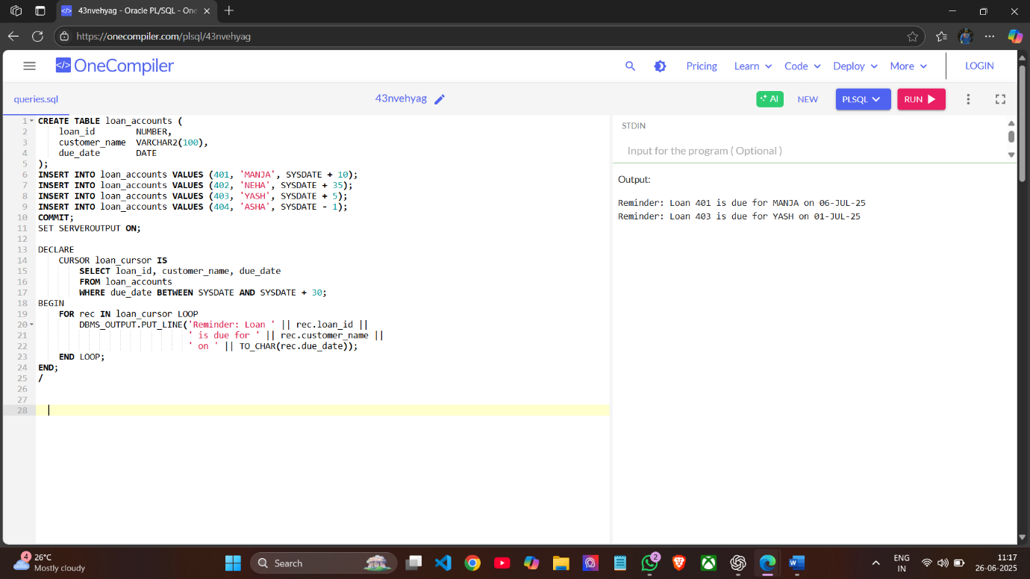

**Exercise 3: Stored Procedures**

**Scenario 1 : The bank needs to process monthly interest for all savings accounts**.

Question : Write a stored procedure ProcessMonthlyInterest that calculates and updates the balance of all savings accounts by applying an interest rate of 1% to the current balance.

**Code for above question:-**

CREATE TABLE Accounts (

AccountID NUMBER,

AccountType VARCHAR2(20),

Balance NUMBER(10, 2)

);

INSERT INTO Accounts VALUES (101, 'SAVINGS', 1000);

INSERT INTO Accounts VALUES (102, 'LOAN', 2000);

INSERT INTO Accounts VALUES (103, 'SAVINGS', 3000);

INSERT INTO Accounts VALUES (104, 'CURRENT', 300000);

INSERT INTO Accounts VALUES (105, 'SAVINGS', 43000);

COMMIT;

CREATE OR REPLACE PROCEDURE ProcessMonthlyInterest IS

v_rows_updated NUMBER;

BEGIN

UPDATE Accounts

SET Balance = Balance + (Balance * 0.01)

WHERE AccountType = 'SAVINGS';

v_rows_updated := SQL%ROWCOUNT;

DBMS_OUTPUT.PUT_LINE(v_rows_updated || ' savings account(s) updated with intrest.');

COMMIT;

END;

/

SET SERVEROUTPUT ON;

BEGIN

ProcessMonthlyInterest;

END;

/

**OUTPUT:**

**  
Scenario 2 : The bank wants to implement a bonus scheme for employees based on their performance.**

Question : Write a stored procedure UpdateEmployeeBonus that updates the salary of employees in a given department by adding a bonus percentage passed as a parameter.

**Code for above question:-**

CREATE TABLE Employees (

EmployeeID NUMBER PRIMARY KEY,

Name VARCHAR2(100),

DepartmentID NUMBER,

Salary NUMBER

);

INSERT INTO Employees VALUES (1, 'Abhi', 101, 50000);

INSERT INTO Employees VALUES (2, 'manjunath', 101, 6000);

INSERT INTO Employees VALUES (3, 'sujay', 102, 55000);

COMMIT;

CREATE OR REPLACE PROCEDURE UpdateEmployeeBonus (

p_DepartmentID IN NUMBER,

p_BonusPercent IN NUMBER

) IS

BEGIN

UPDATE Employees

SET Salary = Salary + (Salary * p_BonusPercent / 100)

WHERE DepartmentID = p_DepartmentID;

COMMIT;

END;

/

BEGIN

UpdateEmployeeBonus(101, 10);

END;

/

SELECT * FROM Employees;

**OUTPUT:**

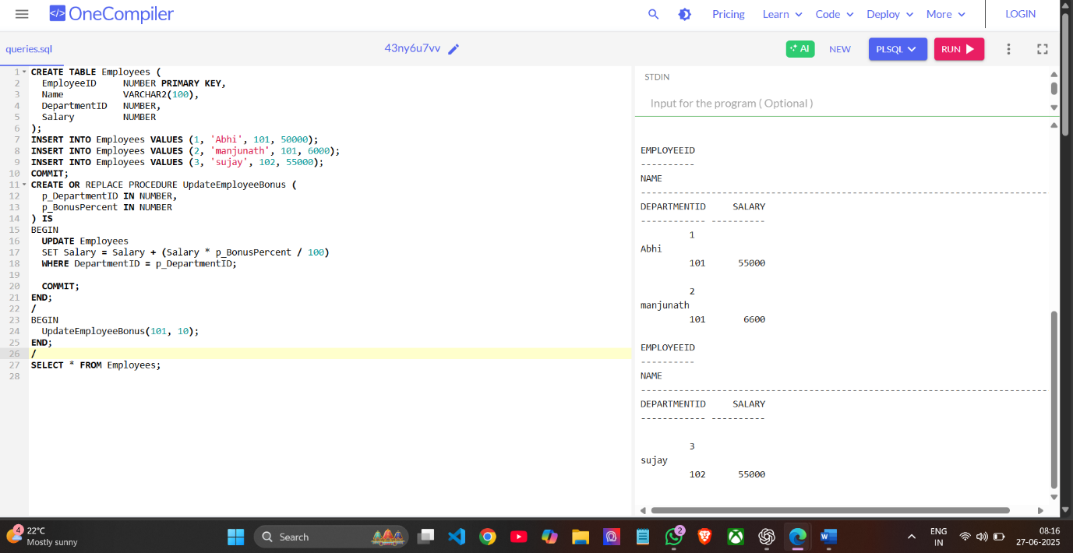

**Scenario 3 : Customers should be able to transfer funds between their accounts.**

Question : Write a stored procedure TransferFunds that transfers a specified amount from one account to another, checking that the source account has sufficient balance before making the transfer.

**Code for above question:-**

CREATE TABLE customer_accounts (

acc_id NUMBER PRIMARY KEY,

holder_name VARCHAR2(50),

balance NUMBER

);

INSERT INTO customer_accounts VALUES (1001, 'Ramesh', 6000);

INSERT INTO customer_accounts VALUES (1002, 'Suresh', 4000);

INSERT INTO customer_accounts VALUES (1003, 'Mahesh', 2000);

COMMIT;

CREATE OR REPLACE PROCEDURE TransferFunds (

sender_id IN NUMBER,

receiver_id IN NUMBER,

amount IN NUMBER

) IS

sender_balance NUMBER;

BEGIN

SELECT balance INTO sender_balance

FROM customer_accounts

WHERE acc_id = sender_id;

IF sender_balance < amount THEN

DBMS_OUTPUT.PUT_LINE('Transfer failed: Not enough balance in sender account.');

RETURN;

END IF;

UPDATE customer_accounts

SET balance = balance - amount

WHERE acc_id = sender_id;

UPDATE customer_accounts

SET balance = balance + amount

WHERE acc_id = receiver_id;

COMMIT;

DBMS_OUTPUT.PUT_LINE(

'Transfer of Rs. ' || amount ||

' from account ' || sender_id ||

' to account ' || receiver_id || ' completed successfully.'

);

EXCEPTION

WHEN NO_DATA_FOUND THEN

DBMS_OUTPUT.PUT_LINE('Transfer failed: Account not found.');

ROLLBACK;

WHEN OTHERS THEN

DBMS_OUTPUT.PUT_LINE('Unexpected error: ' || SQLERRM);

ROLLBACK;

END;

/

BEGIN

TransferFunds(1001, 1002, 1000);

END;

/

BEGIN

TransferFunds(1003, 1002, 5000);

END;

/

**OUTPUT:**

